

**Sequence Game User Manual**

**31/Oct/2016**

**PS: This game was built for Windows machines at the moment.**

**First:** Initialization:

Please keep these two files in one folder.



This is the screen appearance when the game starts:

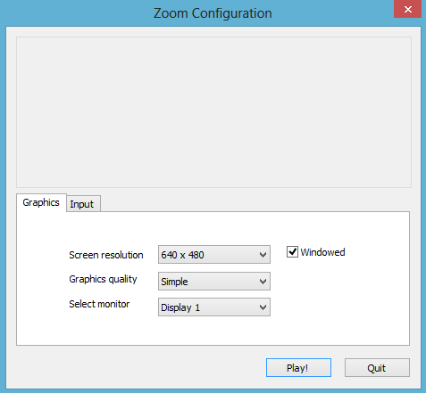

It consists of two main tabs:

* **Graphics: - Input:**

It contains the screen’s resolution, the game’s This tab enables adjusting the controllers.

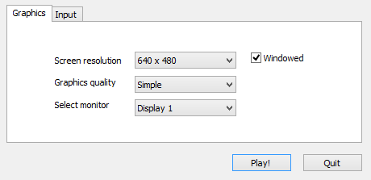quality and its monitor.

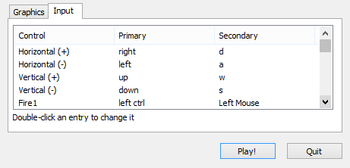

* For the Graphics tab, there are many options for adjusting the screen resolution. The resolution reflects the size of the window if it was open, and it is preferable to keep it around the middle range.

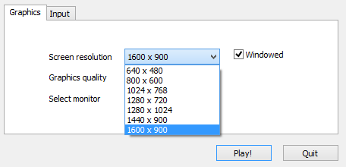

* And adjusting Graphics Quality, if your computer doesn’t have a good graphics card, it’s preferable to keep it between “Simple” and “Good”. For better quality, pick “Fantastic”.

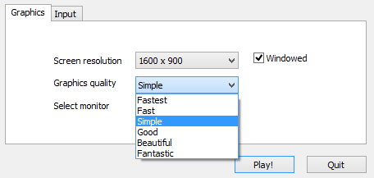

* Please check the small box “Windowed”, so you can end the game easily in case of lagging.

**Second:** Connection:

After adjusting needed settings and clicking on “Play!”, we will see the following screen:

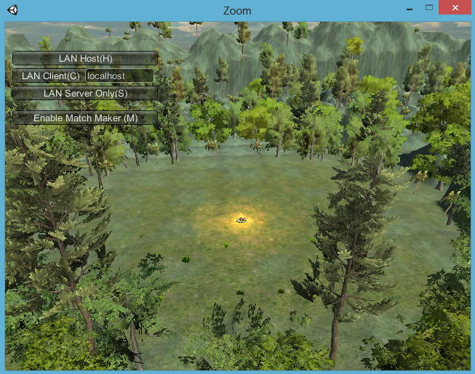

It contains the following buttons:

1. LAN Host (H):
2. LAN Client (C):
3. LAN Server Only (S):
4. Enable Match Maker (M):

**Please follow these steps:**

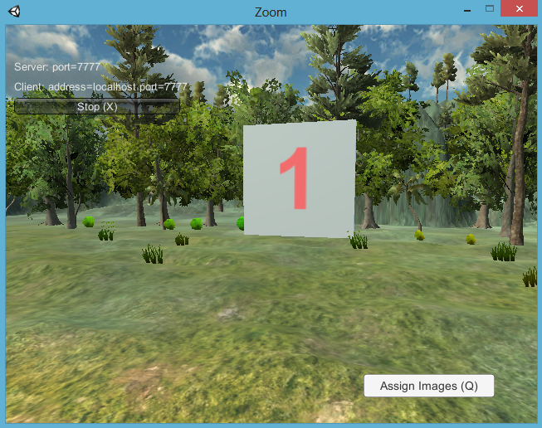**-** The host (the moderator) first joins the game and waits for the other clients (student). Please note that the moderator has the “Assign Images (Q)” button.

- The host (moderator) should obtain his IP Address and give it to others to connect using it. Run the command prompt using the Run command with “cmd” in the text box.

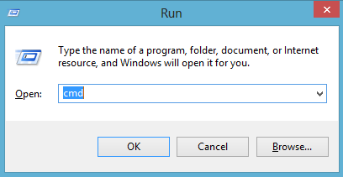

* Then using the black screen command prompt, write the command “ipconfig”. Then obtain the Ethernet adapter IPv4 Address, in this case it is “10.101.8.50”.

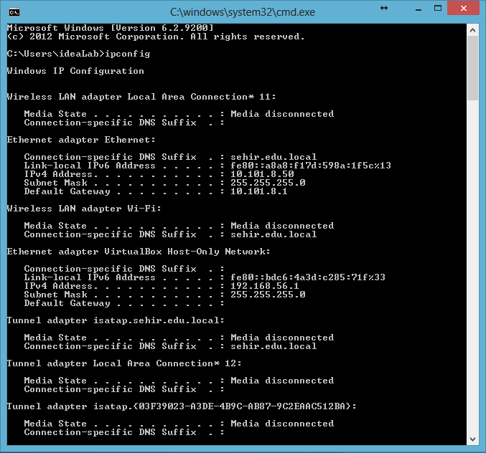

* Then the other clients (students) should connect to the game using the host’s (moderator’s) IP Address in the text box next to the LAN Client (C) option. Then click on the LAN Client (C) button to join the game.

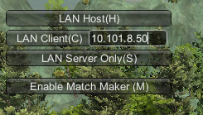

* They should be able to see the IP on the top left of the screen.

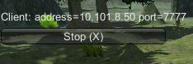

**Third:** Game Play:

The connection have been established, and the host and clients are connected to the Local Network (LAN). Now the game can be played. Characters can walk to the front using the arrows of the letter “W” on the keyboard. Using the mouse to turn right and left.



**Note**: it’s important to mention that the first person who establishes the connection and enter the game is referred to a “Host”, who is the person in charge upon the other players. The “Host” tasks are summarized as following:

1. Distribute the images among players.
2. Support and enhance the collaboration between players.
3. Reveal the final results of players’ corporation.

**How to play:**

* After all players joined successfully, the moderator (Host) will assign images for each player by pressing the letter (Q) on the keyboard. Every player, apart from the host, will get a random image on their screen.

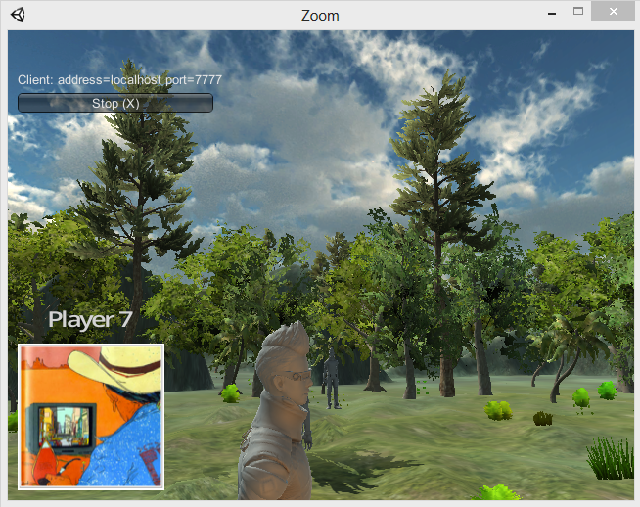

* Every image is part of another image. So, to win, players must arrange the sequence of images within themselves, then they should click on the corresponding board to obtain the right sequence.

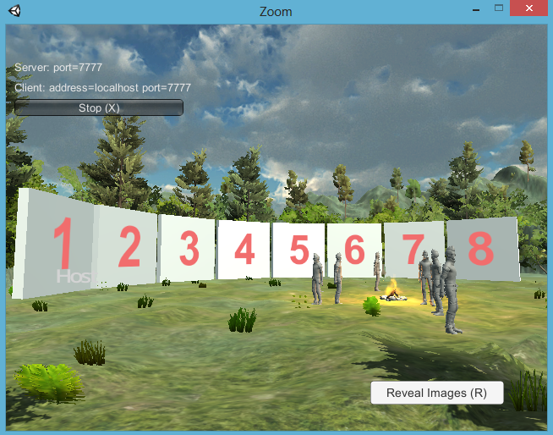

* The boards will have each player’s name. It’s also possible for the clients to change their choice.

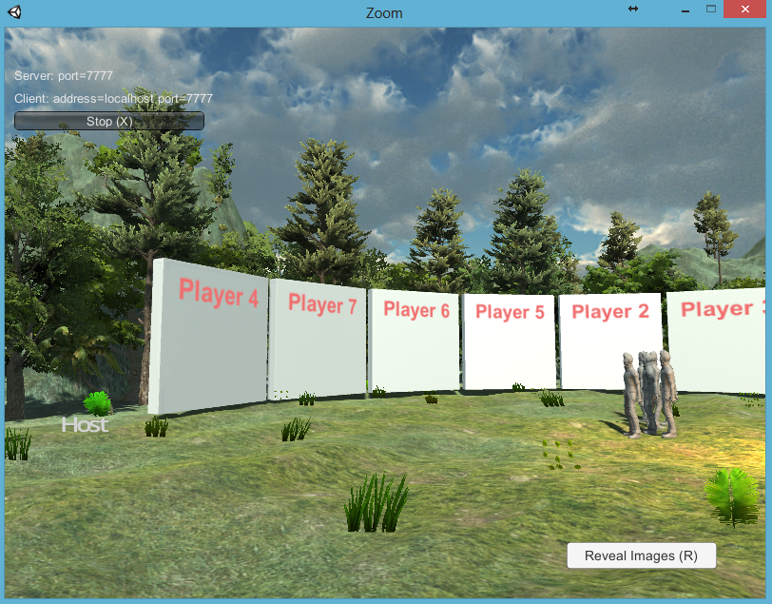

* After that, the moderator should reveal the images by pressing on the letter (R) on the keyboard.

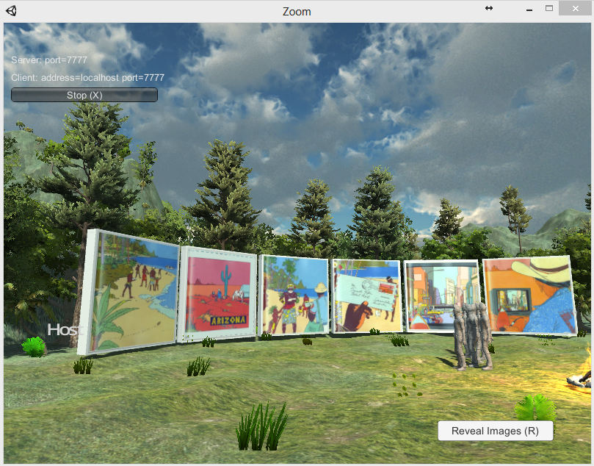

* After that, the moderator should examine the sequence and determine if the team did the right job. Players can still make changes on the boards to give the right sequence.